Indices of Effect Existence and Significance in the Bayesian Framework

# Abstract

Bayesian methods gain increasing attention in psychological sciences. Advantages of Bayesian methods, as opposed to statistical routines from the frequentist framework, are the ability to derive probability statements for every quantity of interest or explicitly incorporate prior knowledge about parameters into the model. These issues are crucial in particular regarding the current debate about statistical significance. Bayesian methods are not necessarily the only remedy against the wrong conclusion that the absence of evidence (statistically non-significant results) do not imply the evidence of absence (“there is no true effect”). But there is an increasing agreement that the Bayesian statistical framework is a good way to go for psychological science to avoid such fallacies. Nevertheless, its flexible nature is its power and weakness, for there is no agreement about what indices should be computed or reported. This lack of a consensual index for the existence of an effect, such as the frequentist *p*-value, further contributes to the unnecessary opacity that many non-familiar readers perceive in Bayesian statistics. Thus, this study describes and compares several indices of effect existence, provide intuitive visual representation of the “behavior” of such indices in relationship with common sources of variance such as sample size and frequentist significance. The results contribute to the development of an intuitive understanding of the values that researchers report and allow to draw recommendations for Bayesian statistics description, critical for the standardization of scientific reporting.

# Introduction

The Bayesian framework is quickly gaining popularity among psychologists and neuroscientists (Andrews & Baguley, 2013). Reasons to prefer this approach are reliability, better accuracy in noisy data, better estimation for small samples, less proneness to type I errors, the possibility of introducing prior knowledge into the analysis and the intuitiveness and straightforward interpretation of results (Dienes & Mclatchie, 2018; Etz & Vandekerckhove, 2016; Kruschke, 2010; Kruschke, Aguinis, & Joo, 2012; Wagenmakers et al., 2018; Wagenmakers, Morey, & Lee, 2016). On the other hand, the frequentist approach has been associated with the focus on *p*-values and null hypothesis significance testing (NHST). The misuse and misinterpretation of p-values, so called ‘p-hacking’ (Simmons, Nelson, & Simonsohn, 2011), ), has been shown to critically contribute to the reproducibility crisis of psychological science (Chambers, Feredoes, Muthukumaraswamy, & Etchells, 2014; Szucs & Ioannidis, 2016). Not only are *p*-values used to draw inappropriate inferences from noisy data. Even if used properly, effects will be drastically overestimated or the direction of effects gets wrong when researchers condition on statistical significance for highly variable data (Gelman, 2018). In response, there is a general agreement that the generalization and utilization of the Bayesian framework is one way of overcoming these issues (Benjamin et al., 2018; Etz & Vandekerckhove, 2016; Halsey, 2019; Marasini, Quatto, & Ripamonti, 2016; Maxwell, Lau, & Howard, 2015; Wagenmakers et al., 2017).

The tenacity and resilience of the *p*-value as an index of significance is remarkable, despite the long-lasting criticism and discussion about its misuse and misinterpretation (Anderson, Burnham, & Thompson, 2000; Cohen, 2016; Fidler, Thomason, Cumming, Finch, & Leeman, 2004; Finch et al., 2004; Gardner & Altman, 1986). This endurance might be informative on how such indices, and the accompanying heuristics applied to interpret them (e.g., assigning thresholds like .05, .01 and .001 to certain levels of significance), are useful and necessary for researchers to gain an intuitive (although possibly simplified) understanding of the interactions and structure of their data. Moreover, the utility of such an index is most salient in contexts where decisions must be made and rationalized (e.g., in medical settings). Unfortunately, these heuristics have severely rigidified, and meeting significance has become a goal unto itself rather than a tool for understanding the data (Cohen, 2016; Kirk, 1996). This is particularly problematic given that *p*-values can only be used to reject the null hypothesis, not to accept it as true (Wagenmakers, 2007). “For several generations, researchers have been warned that a statistically non-significant result does not ‘prove’ the null hypothesis (the hypothesis that there is no difference between groups or no effect of a treatment on some measured outcome)” (Amrhein, Greenland, & McShane, 2019, p. 305).

While significance testing (and its inherent categorical interpretation heuristics) might have its place as a complementary perspective to effect estimation, it does not preclude the fact that drastic improvements are needed. For instance, one possible advance could focus on improving the mathematical understanding (e.g., through a new simpler index) of the values (as opposed to the obscure mathematical definition of the p-value that contributes to its common misinterpretation). Another improvement could be found in providing an intuitive (e.g., visual) understanding of the behavior of the indices in relationship with main sources of variance, such as sample size, noise or effect presence. Such better overall understanding of the indices would hopefully act as a barrier against their mindless reporting by allowing the users to nuance the interpretations and conclusions that they draw.

The Bayesian framework offers some alternative indices for the *p*-value. To better understand these indices, it is important to point out one of the core differences between Bayesian and frequentist methods. From a frequentist perspective, the effects are fixed (but unknown) and data are random. On the other hand, instead of having single estimates of the “true effect”, Bayesian methods compute the probability of different effects given the observed data, resulting in a distribution of possible values for the parameters, called the posterior distribution. The description of the posterior distribution allows to draw conclusions from Bayesian analyses. These results are also affected by prior knowledge, which purpose can be to regularize highly variable data in order to get parameters within a plausible range to avoid overestimation of effects.

Bayesian testing indices could be roughly grouped into three overlapping categories: Bayes factors, posterior indices and ROPE-based indices. Bayes factors are a family of indices of relative evidence of one model over another (e.g., the null vs. the alternative hypothesis; Jeffreys, 1998; Ly, Verhagen, & Wagenmakers, 2016). They provide many advantages over the *p*-value by having a straightforward interpretation as well as allowing to quantify evidence in favor of the null hypothesis (Dienes, 2014; Jarosz & Wiley, 2014). Nonetheless, its use for parameters description in complex models is still a matter of debate (Heck, 2019; Wagenmakers, Lodewyckx, Kuriyal, & Grasman, 2010), and its use is highly dependent on the specification of priors of both compared models (Etz, Haaf, Rouder, & Vandekerckhove, 2018; Kruschke & Liddell, 2018). On the contrary, “posterior indices” reflect objective characteristics of the posterior distribution, for instance the proportion of strictly positive values. While the simplicity of their computation and interpretation is an asset, it also means they are limited in the information that they provide. Importantly, Bayes factors and posterior indices are both the “natural, direct, and unavoidable consequence of Bayes’ rule” (Rouder, Haaf, & Vandekerckhove, 2018, p. 106). Finally, ROPE-based indices are related to the redefinition of the null hypothesis from the classic point-null hypothesis to a range of values considered negligible, or too small to be of any practical relevance (the Region of Practical Equivalence - ROPE; Kruschke (2014); Lakens (2017); Lakens, Scheel, & Isager (2018)), usually spread equally around 0 (e.g., [-0.1; 0.1]). It is interesting to note that this perspective unites Bayesian indices with the focus on effect size (involving a discrete separation between at least two categories: negligible and non-negligible), which finds an echo in recent statistical recommendations (Ellis & Steyn, 2003; Simonsohn, Nelson, & Simmons, 2014; Sullivan & Feinn, 2012).

Despite the richness provided by the Bayesian framework and the availability of multiple indices, no consensus has yet emerged on which ones to be used. Literature continues to bloom in a raging debate, often polarized between proponents of the Bayes factor as the supreme index and its detractors (Robert, 2014, 2016; Spanos, 2013; Wagenmakers, Lee, Rouder, & Morey, 2019), with strong theoretical arguments being developed on both sides. Yet no practical, empirical and direct comparison between these indices has been done. This might be a deterrent for scientists interested in adopting the Bayesian framework. Moreover, this grey area can increase the difficulty of readers or reviewers unfamiliar with the Bayesian framework to follow the assumptions and conclusions, which could in turn generate unnecessary doubt upon the entire study. While we think that such indices of significance and their interpretation guidelines (in the form of rules of thumb) are useful in practice, we also strongly believe that they should be accompanied with the understanding of their “behavior” in relationship with major sources of variance, such as sample size and noise. This knowledge is important for people to implicitly and intuitively appraise the meaning and implication of the mathematical values they report. Such an understanding could prevent the crystallization of the possible heuristics and categories derived from such indices, as has unfortunately occurred for the *p*-values.

Thus, based on the simulation of multiple linear and logistic regressions (arguably some of the most widely used models in the psychological sciences), the present work aims at comparing several indices of effect “significance”, provide visual representations of the “behavior” of such indices in relationship with sample size, noise and effect presence, as well as their relationship to frequentist *p*-values (an index which, beyond its many flaws, is well known and could be used as a reference for Bayesian neophytes), and finally draw recommendations for Bayesian statistics reporting.

# Methods

## Data Simulation

We simulated datasets suited for linear and logistic regression and started by simulating an independent, normally distributed *x* variable (with mean 0 and SD 1) of a given sample size. Then, the corresponding *y* variable was added, having a perfect correlation (in the case of data for linear regressions) or as a binary variable perfect separated by *x*. The case of no effect was simulated by creating a *y* variable that was independent of (i.e. not correlated to) *x*. Finally, a Gaussian noise was added to the *x* variable (the error).

The simulation aimed at modulating the following characteristics: *outcome type* (linear or logistic regression), *sample size* (from 20 to 100 by steps of 10), *null hypothesis* (original regression coefficient from which data is drawn prior to noise addition, 1 - presence of effect, or 0 - absence of effect) and *noise* (Gaussian noise applied to the predictor with SD uniformly spread between 0.666 and 6.66, with 1000 different values). We generated a dataset for each combination of these characteristics, resulting in a total of 36,000 (2 model types * 2 presence/absence of effect * 9 sample sizes * 1,000 noise variations) datasets. The code used for data generation is available on GitHub (<https://github.com/easystats/easystats/tree/master/publications/makowski_2019_bayesian/data>). Note that it takes usually several days/weeks for the generation to complete.

## Indices

For each of these datasets, Bayesian and frequentist regressions were fitted to predict *y* from *x* as a single unique predictor. We then computed the following seven indices from all simulated models, related to the effect of *x*.

### Frequentist *p*-value

This was the only index computed by the frequentist version of the regression. The *p*-value represents the probability that for a given statistical model, when the null hypothesis is true, the effect would be greater than or equal to the observed coefficient (Wasserstein, Lazar, & others, 2016).

### Probability of Direction (*pd*)

The Probability of Direction (*pd*) varies between 50% and 100% and can be interpreted as the probability that a parameter (described by its posterior distribution) is strictly positive or negative (whichever is the most probable). It is mathematically defined as the proportion of the posterior distribution that is of the median’s sign (Makowski, Ben-Shachar, & Lüdecke, 2019).

### MAP-based *p*-value

The *MAP-based p-value* is related to the odds that a parameter has against the null hypothesis (Mills, 2017; Mills & Parent, 2014). It is mathematically defined as the density value at 0 divided by the density at the Maximum A Posteriori (MAP), *i.e.*, the equivalent of the mode for continuous distributions.

### ROPE (95%)

The *ROPE (95%)* refers to the percentage of the 95% HDI that lies within the ROPE. As suggested by Kruschke (2014), the Region of Practical Equivalence (ROPE) was defined as range from -0.1 to 0.1 for linear regressions and its equivalent, -0.18 to 0.18, for logistic models (based on the $π/√(3)$ formula to convert log odds ratios to standardized differences; Cohen, 1988).

### ROPE (full)

The *ROPE (full)* is similar to *ROPE (95%)*, with the exception that refers to the percentage of the *whole* posterior distribution that lies within the ROPE.

### Bayes factor (*vs.* 0)

The Bayes Factor (*BF*) used here is based on prior and posterior distributions of a single parameter. In this context, the Bayes factor indicates the degree by which the mass of the posterior distribution has shifted further away from or closer to the null value(s), relative to the prior distribution, thus indicating if the null hypothesis has become less or more likely given the observed data. We created two indices corresponding to two definitions for the null. In the case of testing against a point null (0), a Savage-Dickey density ratio was computed, which is also an approximation of a Bayes factor comparing the marginal likelihoods of the model against a model in which the tested parameter has been restricted to the point null (Wagenmakers et al., 2010).

### Bayes factor (*vs.* ROPE)

We also computed a *BF* against the range of negligible values (defined here same as for the ROPE indices), by comparing the prior and posterior odds of the parameter falling within vs. outside the ROPE (see *Non-overlapping Hypotheses* in Morey & Rouder, 2011). The formal definition of the *BF (vs. ROPE)* is the ratio between the odds of *ROPE (full)* for the posterior distribution and the odds of *ROPE (full)* for the prior distribution:

$$BF_{rope}=\frac{odds(ROPE_{\text{full posterior}})}{odds(ROPE_{\text{full prior}})}$$

## Data Analysis

The aim of this study is two-fold: 1) compare between Bayesian indices of effect existence and significance, 2) provide visual guides for an intuitive understanding of the numeric values in relation with a known frame of reference (the frequentist *p*-value). Thus, we will start by 1) presenting the relationship between these indices and main sources of variance, such as sample size, noise and null hypothesis. 2) Compare Bayesian indices with the frequentist *p*-value and its commonly used thresholds (.05, .01, .001). Finally, we will show the mutual relationship between 3 recommended candidates. Taken together, these results will help us to outline numeric guides to ease the reporting and interpretation of the indices.

In order to provide an intuitive understanding of values, data processing will focus on creating clear visual figures to help the user grasp the patterns and variability that exists when computing the investigated indices. Nevertheless, we decided to also mathematically test our claims in cases where the graphical representation begged for a deeper investigation. Thus, we fitted two regression models to assess the impact of sample size and noise, respectively. To ensure that any differences between the indices are not due to differences in their scale or differences in their bounds, we converted all indices to the same scale by normalizing the indices between 0 and 1 (note that BFs were transfomed to posterior probabilities) and reversing the *p*-values, the MAP-based *p*-values and the ROPE indices so that a higher value corresponds to stronger “significance”.

The statistical analyses were conducted using R (R Core Team, 2019). Computations of Bayesian models were done using the *rstanarm* package (Goodrich, Gabry, Ali, & Brilleman, 2019), a wrapper for Stan probabilistic language (Carpenter et al., 2017). We used Markov Chain Monte Carlo sampling (in particular, Hamiltonian Monte Carlo (Gelman et al., 2014)) with 4 chains of 2000 iterations, half of which used for warm-up. Mildly informative priors (normal distribution with mean 0 and SD 1) over the parameter were used for the models. The indices were calculated using the *bayestestR* package (Makowski et al., 2019).

# Results

## Impact of Sample Size

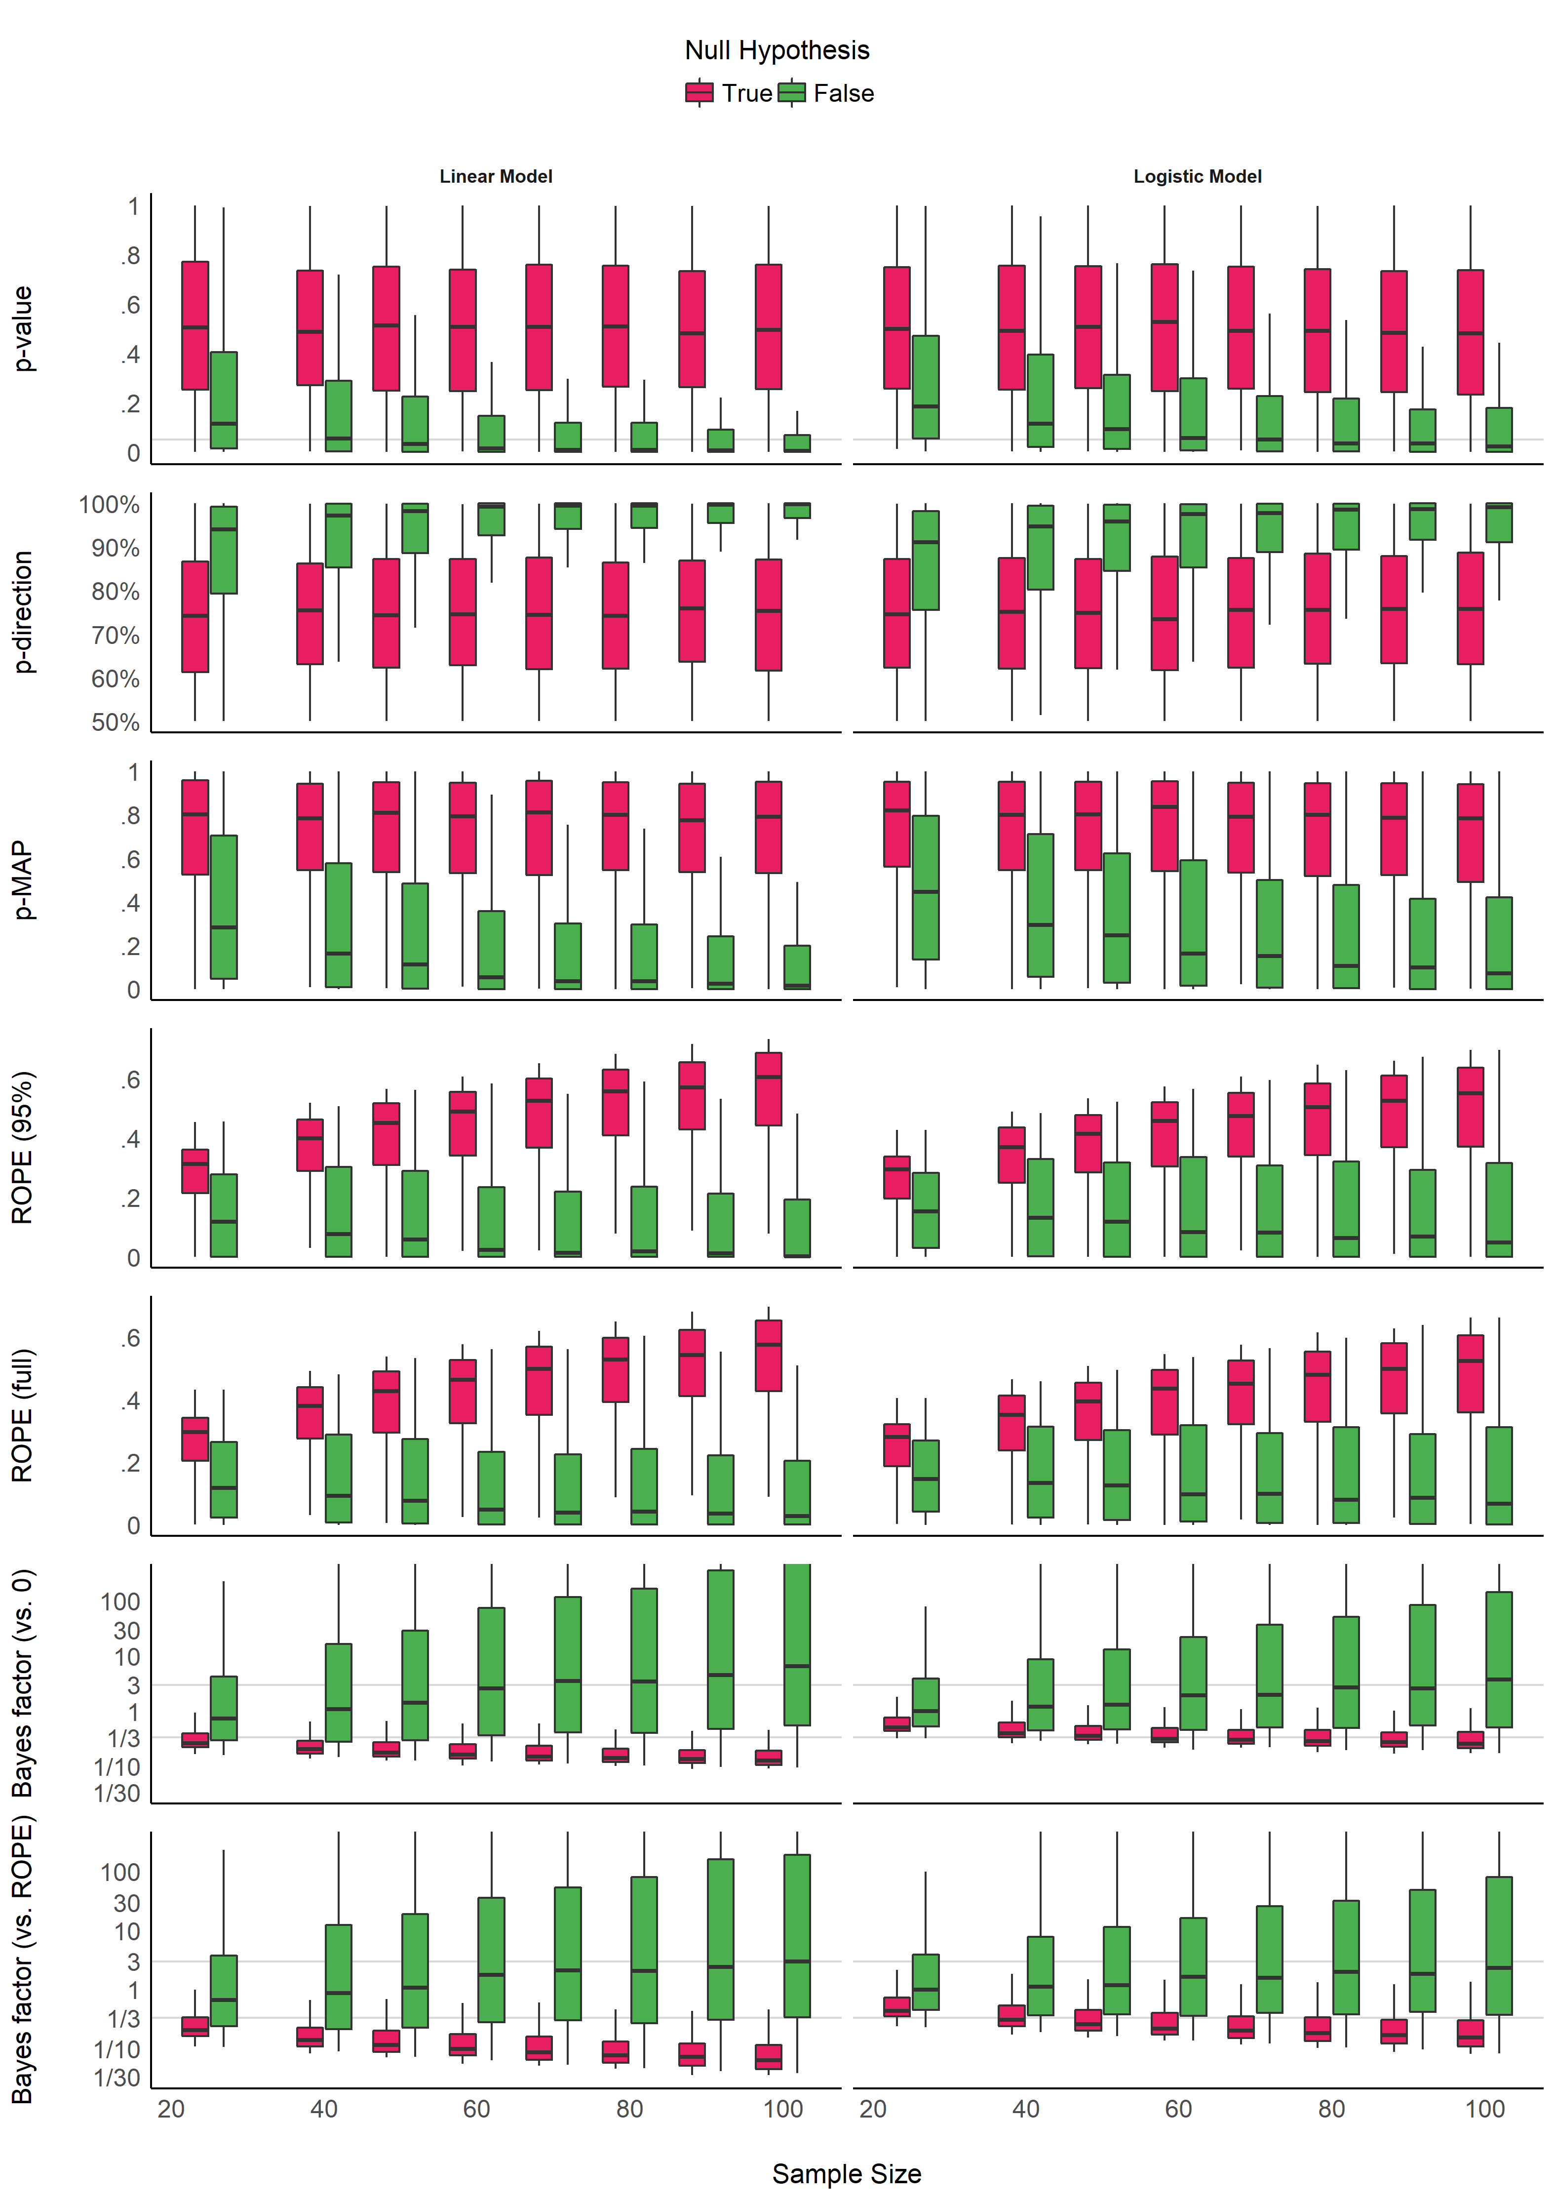

Figure 1. Impact of Sample Size for the different indices, for linear and logistic models, and when the null hypothesis is true or false. Grey vertical lines for p-values and Bayes factors represent commonly used thresholds.

**Figure 1** shows the sensitivity to sample size of the indices. The *p*-value, the *pd* and the MAP-based *p*-value are sensitive to sample size only in case of the presence of a true effect (when the null hypothesis is false). When the null hypothesis is true, all three indices give similar results, independently from sample size. In other words, these indices reflect the amount of evidence (the sample size) for the presence of an effect, but not for its absence. The *ROPE* indices, however, appear as strongly modulated by the sample size when there is no effect, suggesting their sensitivity to the amount of evidence for the absence of effect. Finally, the figure suggests that *BFs* are sensitive to sample size for both presence and absence of true effect.

Table 1. Sensitivity to sample size. This table shows the coefficient between the sample size and the value of each index, adjusted for error, and stratified by model type and presence of true effect. The stronger the coefficient is, the stronger the relationship with sample size.

|  |  |  |  |  |  |
| --- | --- | --- | --- | --- | --- |
|  | Index | Linear Models / Presence of Effect | Linear Models / Absence of Effect | Logistic Models / Presence of Effect | Logistic Models / Absence of Effect |
| 5 | p_value | 0.166 | 0.008 | 0.157 | 0.020 |
| 3 | p_direction | 0.171 | 0.013 | 0.154 | 0.024 |
| 4 | p_MAP | 0.239 | 0.002 | 0.238 | 0.032 |
| 6 | ROPE_95 | 0.033 | 0.359 | 0.008 | 0.310 |
| 7 | ROPE_full | 0.025 | 0.363 | 0.016 | 0.315 |
| 1 | BF_log | 0.198 | 0.116 | 0.116 | 0.141 |
| 2 | BF_ROPE_log | 0.152 | 0.136 | 0.078 | 0.180 |

Consistently with **Figure 1**, the model investigating the sensitivity of sample size on the different indices suggests that *BF* indices are sensitive to sample size both when there is and when there is not an effect. *ROPE* indices are particularly sensitive to sample size when the null hypothesis is true, while *p*-value, *pd* and MAP-based *p*-value are only sensitive to sample size when there is a true effect, in which case they are more sensitive than *ROPE* indices. These findings can be related to the concept of consistency: as the number of data points increases, the statistic converges toward some “true” value. Here, we observe that *p*-value, *pd* and the MAP-based *p*-value are consistent only when the null is false. As sample size increases, they tend to reflect more strongly that the effect is present. On the other hand, *ROPE* indices appear as consistent when the effet is absent. Finally, *BFs* are consistent both when the effect is absent and present. Note also that *BF (vs. ROPE)*, compared to *BF (vs. 0)*, is more sensitive to sample size when the null hypothesis is true, and *ROPE (full)* is overall slightly more consistent than *ROPE (95%)*.

## Impact of Noise

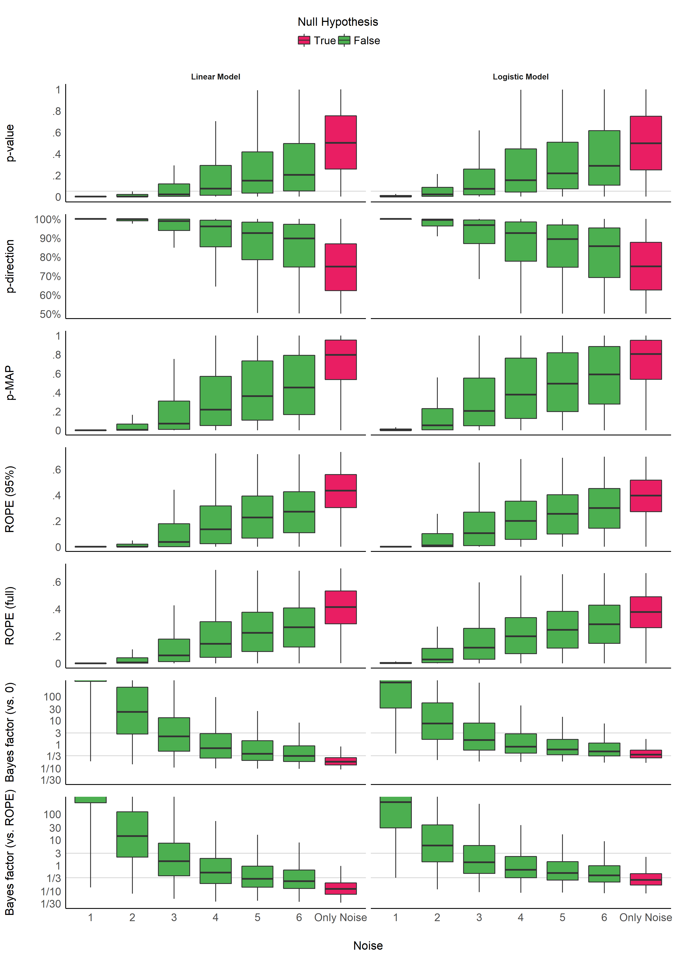

Figure 2. Impact of Noise. The noise corresponds to the standard deviation of the gaussian noise that was added to the generated data. It is related to the magnitude the parameter (the more noise there is, the smaller the coefficient). Grey vertical lines for p-values and Bayes factors represent commonly used thresholds. The scale is capped for the Bayes factors as these extend to infinity.

**Figure 2** shows the sensitivity to noise of the indices. Unlike the patterns of sensitivity to sample size, the indices display more similar patterns in their sensitivity to noise (or magnitude of effects). All indices are unidirectionally impacted by noise: the more noise, the smaller the coefficient, and the less “pronounced” the indices are (respectively to their direction). However, it is interesting to note that the variability of the indices seems differently impacted by noise. For the *p*-values, the *pd* and the ROPE indices, the variability increases as the noise increases. In other words, small coefficients can yield very different values. On the contrary, the variability of BFs decreases as the true effect tends toward 0. For the MAP-based *p*-value, the variability appears to be the highest for moderate amount of noise. This behavior seem consistent accross model types.

Table 2. Sensitivity to noise. This table shows the coefficient between noise and the value of each index when the true effect is present, adjusted for sample size and stratified by model type. The stronger the coefficient is, the stronger the relationship with noise.

|  |  |  |  |
| --- | --- | --- | --- |
|  | Index | Linear Models / Presence of Effect | Logistic Models / Presence of Effect |
| 5 | p_value | 0.35 | 0.40 |
| 3 | p_direction | 0.36 | 0.40 |
| 4 | p_MAP | 0.55 | 0.60 |
| 6 | ROPE_95 | 0.45 | 0.45 |
| 7 | ROPE_full | 0.46 | 0.45 |
| 1 | BF_log | 0.79 | 0.65 |
| 2 | BF_ROPE_log | 0.81 | 0.67 |

Consistently with **Figure 2**, the model investigating the sensitivity of noise when an effect is present (as there is only noise in the absence of effect), adjusted for sample size, suggests that BFs (especially *vs.* ROPE), followed by the MAP-based *p*-value and percentages in *ROPE*, are the most sensitive to noise. As noise is a proxy of effect size (linearly related to the absolute value of the coefficient of the parameter), this result highlights the fact that these indices are sensitive to the magnitude of the effect, whereas the *p*-value and the *pd* would be less sensitive to its magnitude, but rather to its consistency (the certainty of the evidence, as for instance related to the sample size).

## Relationship with the frequentist *p*-value

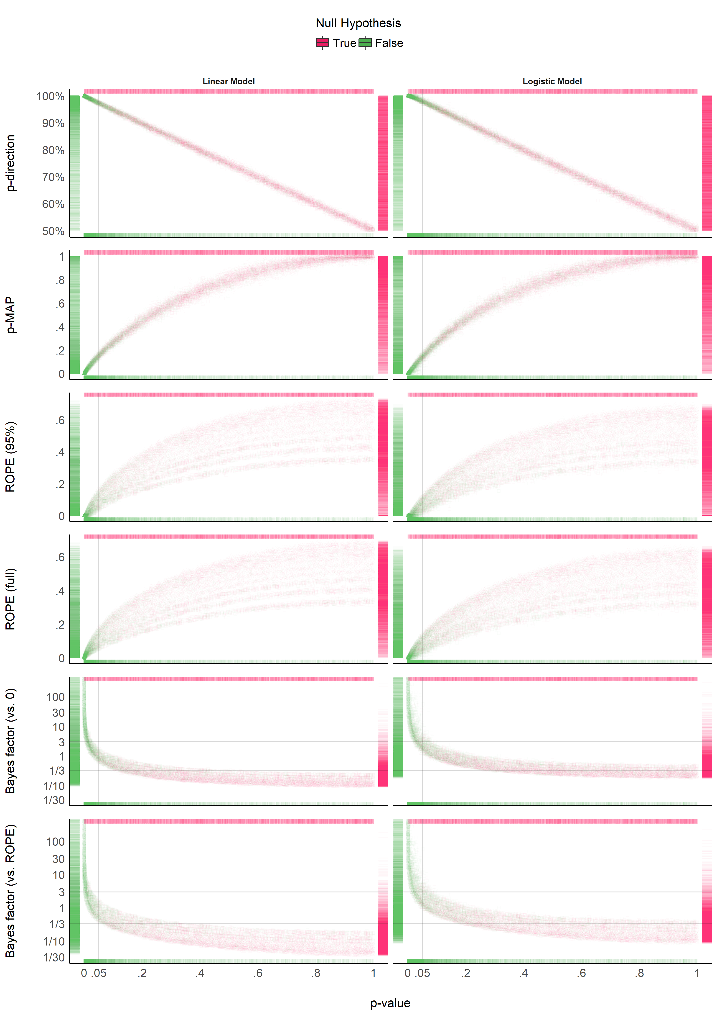

Figure 3. Relationship with the frequentist p-value. In each plot, the p-value densities can be visualized by the marginal top (absence of true effect) and bottom (presence of true effect) markers, whereas on the left (presence of true effect) and right (absence of true effect), the markers represent the density of the index of interest. Different point shapes, representing different sample sizes, specifically illustrate its impact on the percentages in ROPE, for which each “curve line” is associated with one sample size.

**Figure 3** suggests that the *pd* has a 1:1 correspondence with the frequentist *p*-value (through the formula $p_{two−sided}=2*(1−p_{d})$). *BF* indices still appear as having a severely non-linear relationship with the frequentist index. *ROPE*-based percentages appear to be only weakly related to *p*-values. Critically, their relationship seems to be a function of sample size. In other words, the relationship between frequentist significance and the percentage in ROPE depends on the sample size.

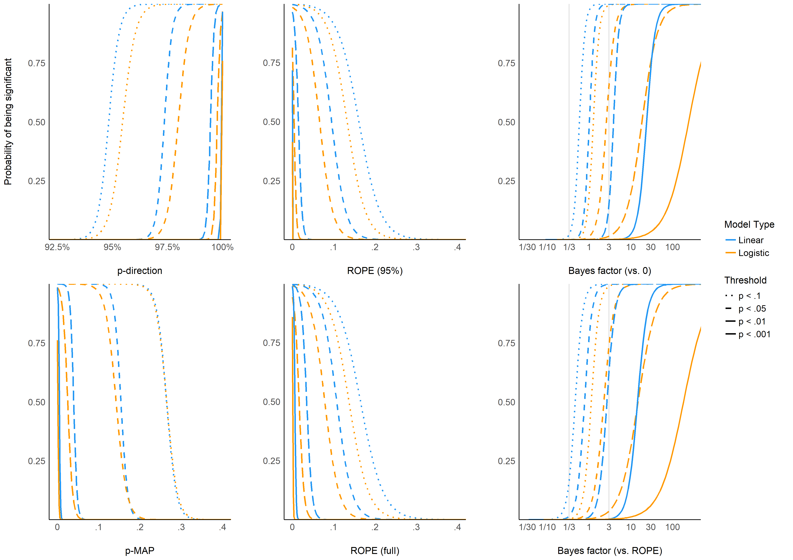

Figure 4. The probability of reaching different p-value based significance thresholds (.1, .05, .01, .001) for different values of the Bayesian indices.

**Figure 4** shows equivalence between *p*-value thresholds (.1, .05, .01, .001) and the Bayesian indices. As expected, the *p*-direction has the sharpest thresholds (95%, 97.5%, 99.5% and 99.95%, respectively). For logistic models, these threshold points appear as more conservative (i.e., Bayesian indices have to be more “pronounced” to reach the same level of significance). This sensitivity to model type is the strongest for BFs (which is possibly related to the difference in the prior specification for these two types of models).

## Relationship between ROPE (full), pd and BF (vs. ROPE)

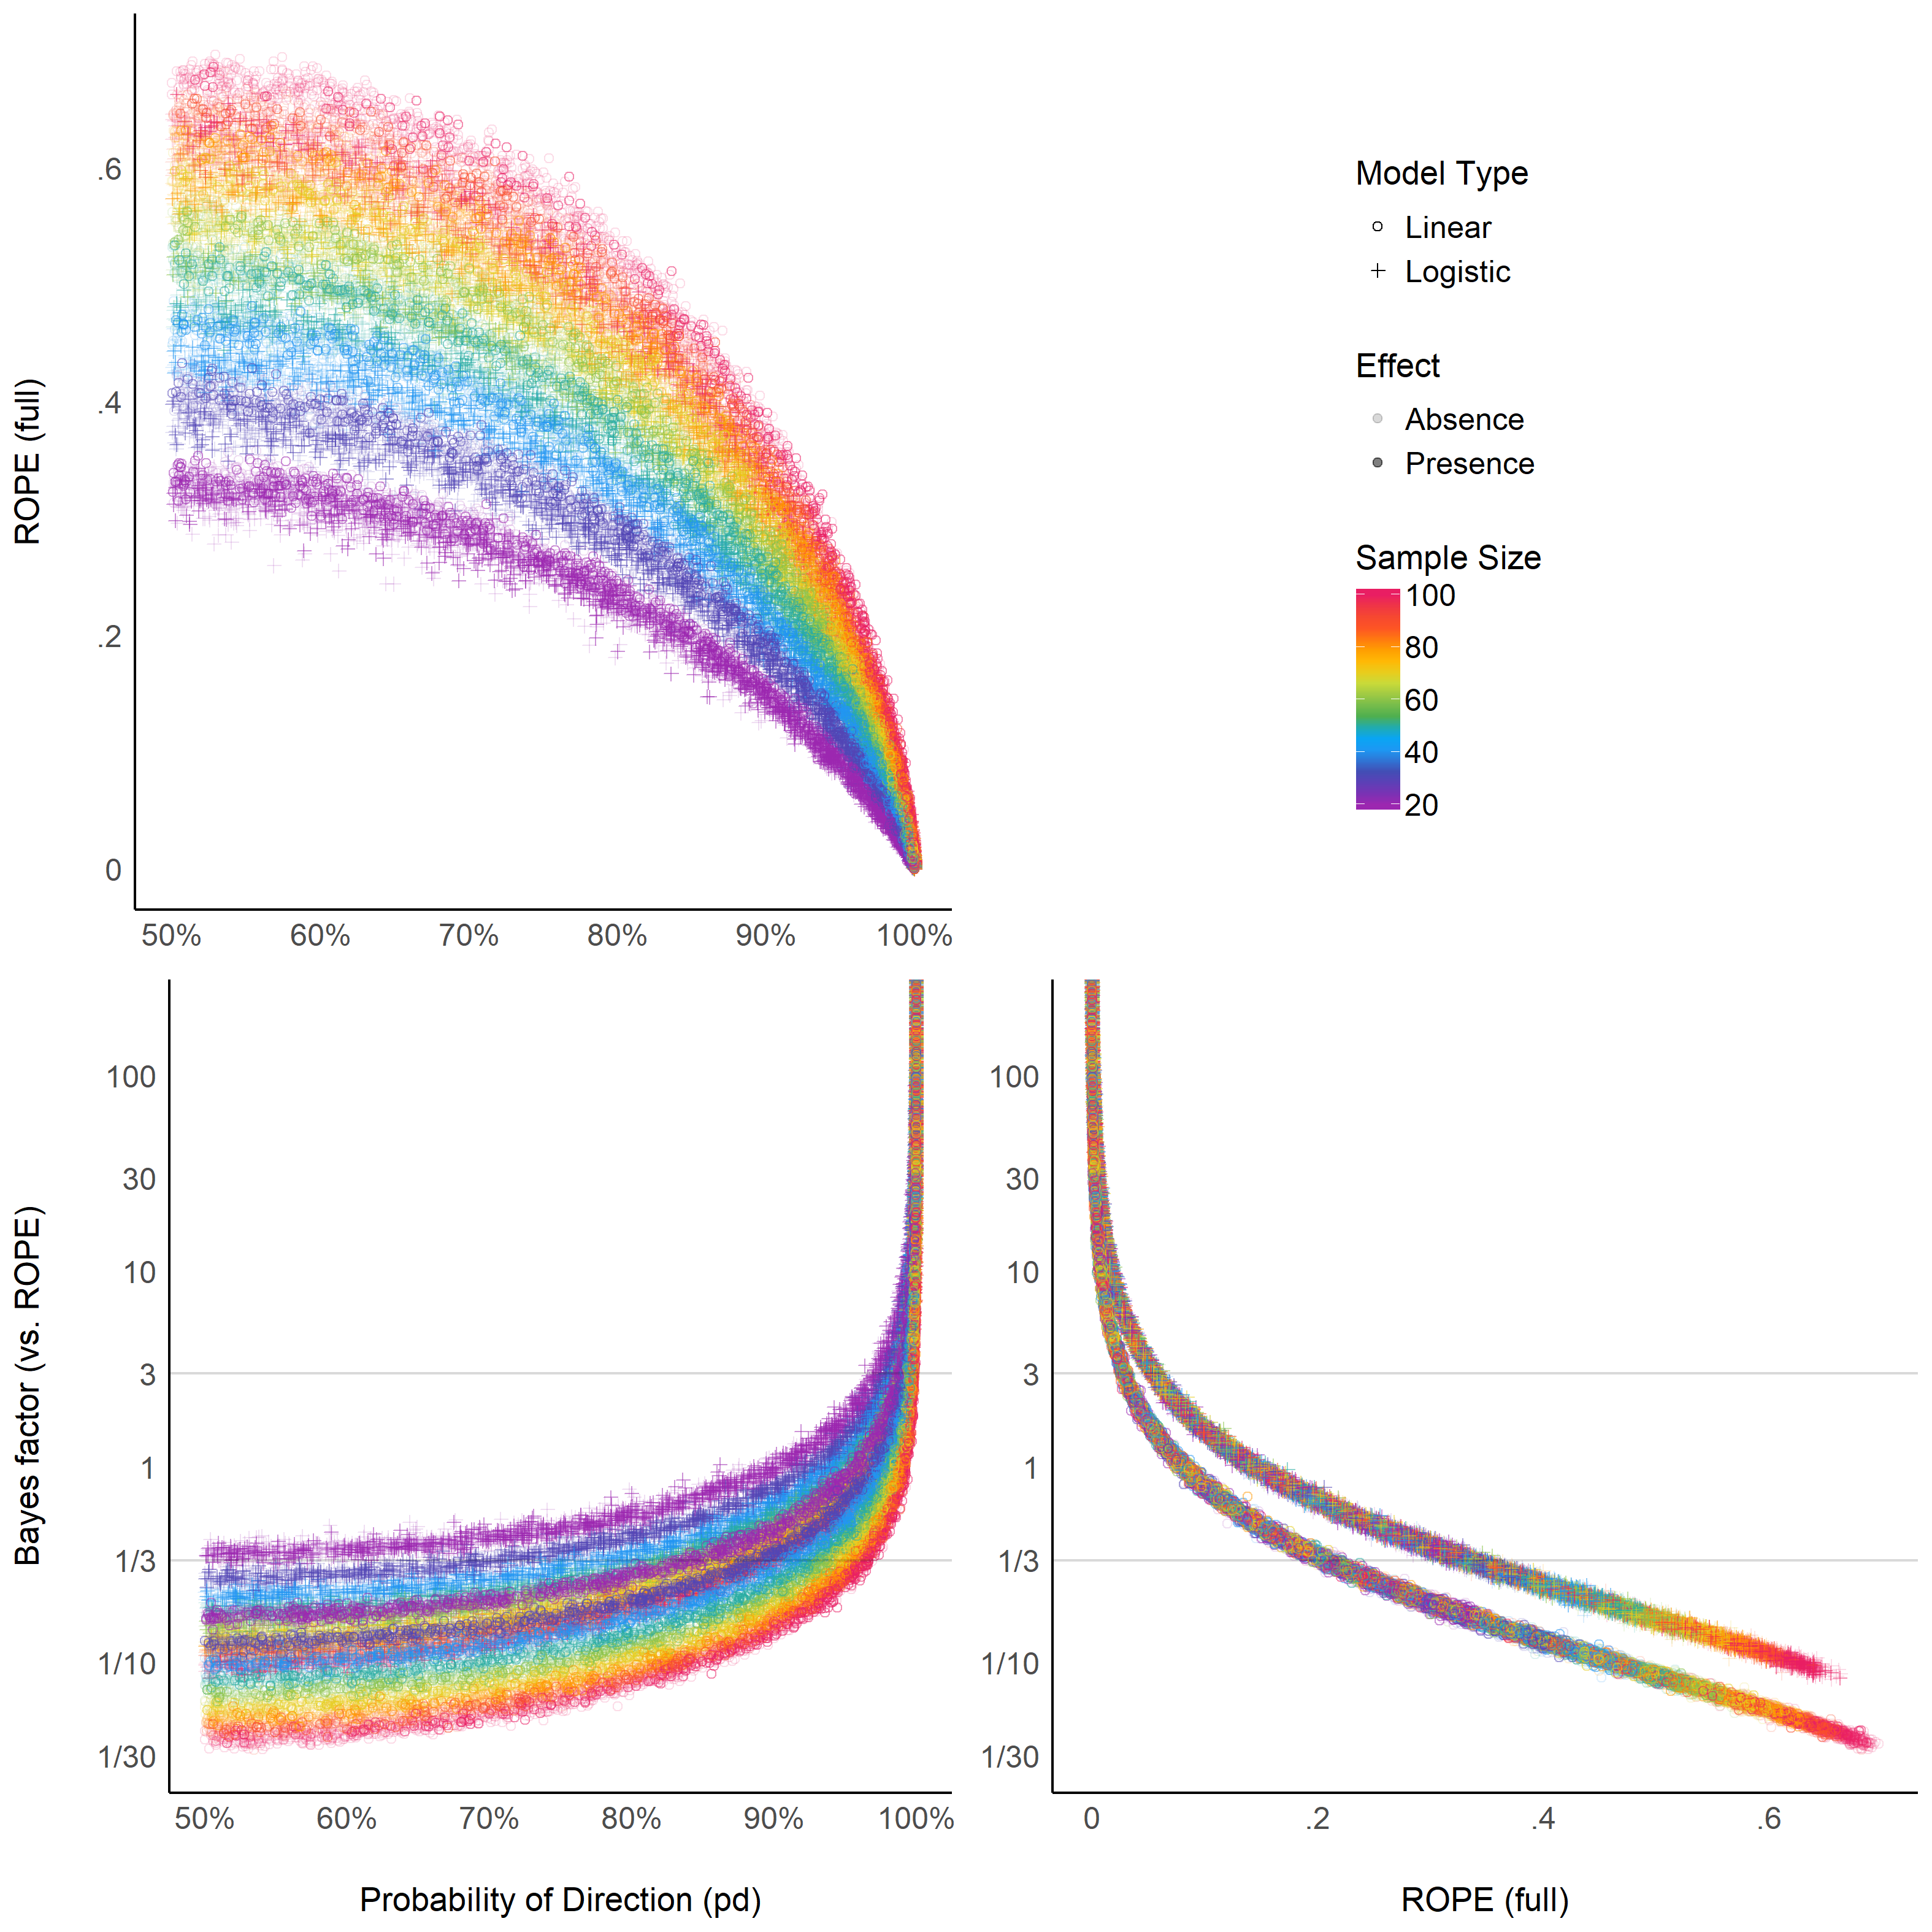

Figure 5. Relationship between three Bayesian indices.

The **Figure 5** suggests that the relationship between the *ROPE (full)* and the *pd* might be strongly affected by the sample size, and the relationship between *BF (vs. ROPE)* and the *pd* might be subject to differences across model types (though see next paragraph). Moreover, the *ROPE (full)* and the *BF (vs. ROPE)* seem very closely related within the same model type. These results reflect *ROPE (full)* and *BF (vs. ROPE)*’s consistency both in case of presence and absence of a true effect, where the *pd*, being equivalent to the *p*-value, is only consistent when the true effect is absent.

# Discussion

Based on the simulation of linear and logistic models, the present work aimed at comparing several Bayesian indices of effect “significance” (see **Table 3**), providing visual representations of the “behavior” of such indices in relationship with important sources of variance such as sample size, noise and effect presence, as well as comparing them with the well-known and widely used frequentist *p*-value and its arbitrary interpretation thresholds.

The results tend to suggest that the investigated indices could be separated into 2 categories: the first group, including the *pd* and the MAP-based *p*-value, presents similar properties to those of the frequentist *p*-value (Rouder & Morey, 2012; Rouder, Speckman, Sun, Morey, & Iverson, 2009). They are sensitive to the amount of evidence for the alternative hypothesis only (i.e., when an effect is trully present). In other words, these indices are not able to reflect the amount of evidence in favor of the null hypothesis. A high value suggest that the effect exists, but a low value indicates *uncertainty* about its existence (but not certainty that it is non-existing). The second group, including percentages in ROPE and Bayes factors, seem sensitive both to presence and absence of effect, accumulating evidence as the sample size increases. However, the percentage in ROPE seems particularly suited to provide evidence in favor of the null hypothesis. Consistently with this, combining Bayes factors with the ROPE (BF *vs.* ROPE), as compared to Bayes factors against the point-null (BF *vs.* 0), leads to a higher sensitivity to null-effects (Morey & Rouder, 2011; Rouder & Morey, 2012).

We also showed that besides sharing similar properties, the *pd* has a 1:1 correspondence with the frequentist *p*-value, being its true Bayesian equivalent. On the contrary Bayes factors appear as having a severely non-linear relationship with the frequentist index, which is to be expected from their mathematical definition and their sensitivity when the null hypothesis is true. This in turn can lead to suprising conclusions. For instance, Bayes factors lower than 1, which are considered as providing evidence *against* the presence of an effect, can still correpond to a “significant” frequentist *p*-value (see **Figure 4**). Percentages in ROPE are the indices the more losely related to the *p*-value, as it appears as depending on another factor, the sample size. This suggests that the percentage in ROPE encapsulates additional information about the strength of evidence.

What is the point of comparing Bayesian indices with the frequentist *p*-value, especially after having pointed out to its many flaws? While this comparison may seem counter-intuitive (as Bayesian thinking is intrinsically different from the frequentist framework), we believe that this juxtaposition is interesting for didactic reasons. The frequentist *p*-value “speaks” to many and can thus be seen as a reference and a way to facilitate the shift toward the Bayesian framework. Thus, pragmatically documenting such bridges can only foster the understanding of the methodological issues that our field is facing, and in turn act against the sectarism and isolation caused by a dogmatic approach to a framework. This does not preclude, however, that a change in the general paradigm of significance seeking in necessary, and that Bayesian indices are fundamentally different from the frequentist *p*, rather than mere approximations or equivalents.

Table 3. Summary of Bayesian Indices of Effect Existence and Significance.

|  |  |  |  |  |
| --- | --- | --- | --- | --- |
| Index | Interpretation | Definition | Strengths | Limitations |
| Probability of Direction (pd) | Probability that an effect is of the same sign as the median’s. | Proportion of the posterior distribution of the same sign than the median’s. | Straightforward computation and interpretation. Objective property of the posterior distribution. 1:1 correspondence with the frequentist p-value. | Limited information favoring the null hypothesis. |
| MAP-based p-value | Relative odds of the presence of an effect against 0. | Density value at 0 divided by the density value at the mode of the posterior distribution. | Straightforward computation. Objective property of the posterior distribution | Limited information favoring the null hypothesis. Relates on density approximation. Indirect relationship between mathematical definition and interpretation. |
| ROPE (95%) | Probability that the credible effect values are not negligible. | Proportion of the 95% CI inside of a range of values defined as the ROPE. | Provides information related to the practical relevance of the effects. | A ROPE range needs to be arbitrarily defined. Sensitive to the scale (the unit) of the predictors. Not sensitive to highly significant effects. |
| ROPE (full) | Probability that the effect possible values are not negligible. | Proportion of the posterior distribution inside of a range of values defined as the ROPE. | Provides information related to the practical relevance of the effects. | A ROPE range needs to be arbitrarily defined. Sensitive to the scale (the unit) of the predictors. |
| Bayes factor (vs. 0) | The degree by which the probability mass has shifted away from or towards the null value, after observing the data. | Ratio of the density of the null value between the posterior and the prior distributions. | An unbounded continuous measure of relative evidence. Allows statistically supporting the null hypothesis. | Sensitive to selection of prior distribution shape, location and scale. |
| Bayes factor (vs. ROPE) | The degree by which the probability mass has shifted away from or towards the null interval (ROPE), after observing the data. | Ratio of the odds of the posterior vs the prior distribution falling inside of the range of values defined as the ROPE. | An unbounded continuous measure of relative evidence. Allows statistically supporting the null hypothesis. Compared to the BF (vs. 0), evidence is accumulated faster for the null when the null is true. | A ROPE range needs to be arbitrarily defined. Sensitive to the scale (the unit) of the predictors. Sensitive to selection of prior distribution shape, location and scale. |

Critically, while the purpose of these indices was solely referred to as *significance* until now, we would like to emphasize the nuanced perspective of the existence-significance testing as a dual-framework for parameters description and interpretation. The idea supported here is that there is a conceptual and practical distinction, and possible dissociation to be made, between an effect’s existence *and* significance. In this context, *existence* is simply defined as the consistency of an effect in one particular direction (i.e., positive or negative), without any assumptions or conclusions as to its size, importance, relevance or meaning. It is an objective feature of an estimate (tied to its uncertainty). On the other hand, *significance* would be here re-framed following its original literally definition such as “being worthy of attention” or “importance”. An effect can be considered significant if its magnitude is higher than a given threshold. This aspect can be explored, to a certain extent, in an objective way with the concept of *practical equivalence* (Kruschke, 2014; Lakens, 2017; Lakens et al., 2018), which suggests the use of a range of values assimilated to the absence of an effect (the ROPE). If the effect falls within this range, it is considered as non-significant *for practical reasons*: the magnitude of the effect is likely to be too small to be of high importance in real-world scenarios. Nevertheless, *significance* also withholds a more subjective aspect, corresponding to its contextual meaningfulness and relevance. This, however, is usually dependent on the literature, priors, novelty, context or field, and thus cannot be objectively or neutrally assessed with a statistical index.

While indices of significance and existence can be numerically related (as shown in our results), they are conceptually independent. For example, an effect for which the whole posterior distribution is concentrated within the [0.0001, 0.0002] range would be considered as positive with a high certainty (and thus, *existing* in a that direction), but also not significant (i.e., too small to be of any practical relevance). Acknowledging the distinction and complementary of these two aspects can in turn enrich the information and usefulness of the results reported in psychological science (for practical reasons, the implementation of this dual-framework of existence-significance testing is made straightforward through the *bayestestR* open-source package for R; Makowski et al., 2019). In this context, the *pd* and the MAP-based *p*-value appear as indices of effect existence, mostly sensitive to the certainty related to the direction of the effect. ROPE-based indices and Bayes factors are indices of effect significance (related to the magnitude and the amount of evidence in favor of it).

The inherent subjectivity related to the assessment of significance is one of the practical limitation the ROPE-based indices (although being, conceptually, an asset, allowing for contextual nuance in the interpretation), as they require an explicit definition of the non-significant range (the ROPE). Although default values were reported in the literature (for instance, half of a “negligible” effect size reference value; Kruschke, 2014), it is critical for the reproducibility and transparency that the researcher’s choice is explicitly stated (and, if possible, justified). Beyond being arbitrary, this range also has hard bounds (for instance, contrary to a value of 0.0499, a value of 0.0501 would be considered as non-negligible). This reinforces a categorical and clustered perspective of what is by essence a continuous space of possibilities. Importantly, as this range is fixed to the scale of the outcome response (in is expressed in the unit of the outcome), these indices are sensitive to changes in the scale of the predictors. In other words, as the ROPE represents a fixed portion of the response’s scale, it is dependent on the scale of the predictor. For instance, in the case of a simple linear regression, for which the median of the coefficient of *x* on *y* is of 0.02 and falls within the ROPE (being not significant), simply multiplying *x* values by 100 would result in a coefficient with a median of 0.02 * 100 = 20, which would fall outside of the rope (which range is fixed to *y*), that one inattentive or malicious researcher could misleadingly present as “significant” (note that indices of existence, such as the *pd*, would not be affected). Finally, the ROPE definition is also dependent on the model type, and selecting a consistent or homogeneous range for all the families of models is not straightforward. This, in turn, can make comparisons between model types difficult, and an additional burden when interpreting ROPE-based indices. In summary, while a well-defined ROPE can be a powerful tool to give a different and new perspective, it also requires extra caution from the authors and the readers.

As for the difference between ROPE (95%) and ROPE (full), we suggest reporting the latter (i.e., the percentage of the whole posterior distribution that falls within the ROPE instead of a given proportion of CI). This bypass the usage of another arbitrary range (95%) and appears to be more sensitive to delineate highly significant effects). Critically, rather than using the percentage in ROPE as a dichotomous, all-or-nothing decision criterion, such as suggested by the original equivalence test (Kruschke, 2014), we recommend using the percentage as a continuous index of significance (with an explicitly specified cut-off point if categorization is needed, for instance 5%).

Our results underline Bayes factor as an interesting index, able to provide evidence in favor or against the presence of an effect. Moreover, its easy interpretation in terms of odds in favor, or against, one or the other hypothesis makes it a compelling index for communication. Nevertheless, one of the main critiques of Bayes factors, is its sensitivity to priors (shown in our results here through its sensitivity to model types, as priors odds for logistic and linear models are different). Moreover, while the BF against a ROPE appears as even better than the BF against a point-null, it also carries all the limitations related to the ROPE specification mentioned above. Thus, we recommend using Bayes factors (preferentially *vs* a ROPE) if the user has explicitly specified informative priors. The relative similarity between the Bayes factor against ROPE and the percentage in ROPE (full) is expected due to their mathematical relationship, as the former can be computed as the odds of the latter divided by the *prior* odds falling within the ROPE. Since the prior odds is dependent only on the shape of the prior distributions and the definition of the range of the ROPE, it is a constant that normalizes the posterior ROPE odds relative to the prior ROPE odds.

Being quite different from the Bayes factors and the ROPE indices, the Probability of Direction (*pd*) is an index of effect existence representing the certainty with which an effect goes in a particular direction (*i.e.*, is positive or negative). Beyond its simplicity of interpretation, understanding and computation, this index also presents other interesting properties. It is independent from the model, *i.e.*, it is solely based on the posterior distributions and does not require any additional information from the data or the model. Contrary to ROPE-based indices, it is robust to the scale of both the response variable and the predictors. Nevertheless, this index also presents some limitations. Most importantly, the *pd* is not relevant to assess size or importance and is not enable to give information in favor of the null. In other words, a high *pd* suggests the presence of an effect but a small *pd* does not give us any information about how much the null hypothesis is plausible, suggesting that this index can only be used to eventually “reject the null” (but not accepting it, which is consistent with the interpretation of the frequentist *p*-value). On the contrary, the BFs (and to some extent the percentage in ROPE, although being bounded to 0% and 100%) continue increasing or decreasing as the evidence becomes stronger (more data points), in both directions.

Much of these strengths also apply to the MAP-based *p*-value. Although possibly showing some superiority in terms of sensitivity as compared to the *pd*, it also presents an important limitation. Indeed, the MAP is mathematically dependent on the density at 0 and at the mode. However, the density estimation of a continuous distribution is a statistical problem on its own and many different methods exist. It is possible that changing the density estimation might impact the MAP-based *p*-value with unknown results. Additionally, the *pd* has a linear relationship with the frequentist *p*-value, which is in our opinion an asset.

After all the criticism regarding the frequentist *p*-value, it might appear as counter-intuitive to suggest the usage of its Bayesian empirical equivalent. The subtler perspective that we support is that the *p*-value is not an intrinsically bad, or wrong, index. Instead, it is its misuse, misunderstanding and misinterpretation that fuels, in our opinion, the decay of the situation into the crisis. Interestingly, the proximity between the *pd* and the *p*-value suggests that the latter is more an index of effect *existence* than *significance* (*i.e.*, “worth of interest”). Addressing this confusion, the Bayesian equivalent has an intuitive meaning and interpretation, making also obvious the fact that all thresholds and heuristics are arbitrary. Additionally, its mathematical and interpretative transparency of the *pd*, and its conceptualization as an index of effect existence, offers a valuable insight into the characterization of Bayesian results, and its practical proximity with the frequentist *p*-value makes it a perfect metric to ease the transition of psychological research into the adoption of the Bayesian framework.

# Reporting Guidelines

How these observations can be used to improve statistical good practices in psychological science? Importantly, before being able to draw a definitive conclusion about the qualities of these indices, further studies need to investigate the robustness of these indices to sampling characteristics (*e.g.*, sampling algorithm, number of iterations, chains, warm-up) and the impact of prior specification (Kass & Raftery, 1995; Kruschke, 2011; Vanpaemel, 2010), all of which are important parameters of Bayesian statistics.

Nevertheless, based on the present comparison, we can start outlining the following guidelines. As the two aspects of the EXIT framework, *existence* and *significance*, are complementary, we suggest using at minimum one index of each category. As an objective index of effect existence, the *pd* should be reported, for its simplicity of interpretation, its robustness and its numeric proximity to the well-known frequentist *p*-value; As an index of significance either the *BF (vs. ROPE)* or the *ROPE (full)* should be reported, for their ability to discriminate between presence and absence of effect (De Santis, 2007), and the information they provide related to evidence of the size of the effect. Selection between the the *BF (vs. ROPE)* or the *ROPE (full)* should depend on the imformitness of the priors used - when uninformative priors are used, and there is little prior knowledge regarding the expected size of the effect, the *ROPE (full)* should be reported as it reflects only the posterior distribution, and is not sensitive to the width of a wide-range of prior scales (REF??). On the other hand, in cases where informed prior are used, reflecting prior knowledge regarding the expected size of the effect, *BF (vs. ROPE)* should be used.

Defining appropriate heuristics to help the interpretation is beyond the scope of this study, as it would require testing them on more natural datasets. Nevertheless, if we take the frequentist framework and the existing literature as a reference point, it seems that 95%, 97% and 99% might be relevant reference points (i.e., easy-to-remember values) for the *pd* and 3, 10 and 30 (weak evidence) appropriate for the BF. A concise, standardized, reference template sentence to describe the parameter of a model including an index of point-estimate, uncertainty, existence, significance and effect size (Cohen, 1988) could be, in the case of *pd* and *BF*:

“There is moderate evidence (BFROPE = 0.29) [*BF (vs. ROPE)*] in favour of an absence of effect of X, which has a probability of 90.14% [*pd*] of being negative (Median = -0.03, 89% CI [-0.05, 0.01]), and can be considered as very small (Std. Median = -0.09) [*standardized coefficient*] [*optional*: and not-significant (6.42% in ROPE) [*ROPE (full)*]]”

# Supplementary Materials

The full R code used for data generation, data processing, figures creation and manuscript compiling is available on Github at <https://github.com/easystats/easystats/tree/master/publications/makowski_2019_bayesian>.

# Acknowledgments

This study was made possible by the development of the **bayestestR** package, itself part of the *easystats* ecosystem (Lüdecke, Waggoner, & Makowski, 2019), an open-source and collaborative project created to facilitate the usage of R. Thus, we would like to thank the masters of easystats, the other padawan contributors, as well as the users.

# References

Amrhein, V., Greenland, S., & McShane, B. (2019). Scientists rise up against statistical significance. *Nature*, *567*(7748), 305–307. <https://doi.org/10.1038/d41586-019-00857-9>

Anderson, D. R., Burnham, K. P., & Thompson, W. L. (2000). Null hypothesis testing: Problems, prevalence, and an alternative. *The Journal of Wildlife Management*, 912–923.

Andrews, M., & Baguley, T. (2013). Prior approval: The growth of bayesian methods in psychology. *British Journal of Mathematical and Statistical Psychology*, *66*(1), 1–7.

Benjamin, D. J., Berger, J. O., Johannesson, M., Nosek, B. A., Wagenmakers, E.-J., Berk, R., … others. (2018). Redefine statistical significance. *Nature Human Behaviour*, *2*(1), 6.

Carpenter, B., Gelman, A., Hoffman, M. D., Lee, D., Goodrich, B., Betancourt, M., … Riddell, A. (2017). Stan: A Probabilistic Programming Language. *Journal of Statistical Software*, *76*(1). <https://doi.org/10.18637/jss.v076.i01>

Chambers, C. D., Feredoes, E., Muthukumaraswamy, S. D., & Etchells, P. (2014). Instead of ’playing the game’ it is time to change the rules: Registered reports at aims neuroscience and beyond. *AIMS Neuroscience*, *1*(1), 4–17.

Cohen, J. (1988). *Statistical power analysis for the social sciences*.

Cohen, J. (2016). The earth is round (p<. 05). In *What if there were no significance tests?* (pp. 69–82). Routledge.

De Santis, F. (2007). Alternative bayes factors: Sample size determination and discriminatory power assessment. *Test*, *16*(3), 504–522.

Dienes, Z. (2014). Using bayes to get the most out of non-significant results. *Frontiers in Psychology*, *5*, 781.

Dienes, Z., & Mclatchie, N. (2018). Four reasons to prefer bayesian analyses over significance testing. *Psychonomic Bulletin & Review*, *25*(1), 207–218.

Ellis, S., & Steyn, H. (2003). Practical significance (effect sizes) versus or in combination with statistical significance (p-values): Research note. *Management Dynamics: Journal of the Southern African Institute for Management Scientists*, *12*(4), 51–53.

Etz, A., Haaf, J. M., Rouder, J. N., & Vandekerckhove, J. (2018). Bayesian inference and testing any hypothesis you can specify. *Advances in Methods and Practices in Psychological Science*, 2515245918773087.

Etz, A., & Vandekerckhove, J. (2016). A bayesian perspective on the reproducibility project: Psychology. *PloS One*, *11*(2), e0149794.

Fidler, F., Thomason, N., Cumming, G., Finch, S., & Leeman, J. (2004). Editors can lead researchers to confidence intervals, but can’t make them think: Statistical reform lessons from medicine. *Psychological Science*, *15*(2), 119–126.

Finch, S., Cumming, G., Williams, J., Palmer, L., Griffith, E., Alders, C., … Goodman, O. (2004). Reform of statistical inference in psychology: The case ofMemory & cognition. *Behavior Research Methods, Instruments, & Computers*, *36*(2), 312–324.

Gardner, M. J., & Altman, D. G. (1986). Confidence intervals rather than p values: Estimation rather than hypothesis testing. *Br Med J (Clin Res Ed)*, *292*(6522), 746–750.

Gelman, A. (2018). The Failure of Null Hypothesis Significance Testing When Studying Incremental Changes, and What to Do About It. *Personality and Social Psychology Bulletin*, *44*(1), 16–23. <https://doi.org/10.1177/0146167217729162>

Gelman, A., Carlin, J. B., Stern, H. S., Dunson, D. B., Vehtari, A., & Rubin, D. B. (2014). *Bayesian data analysis.* (Third edition). Boca Raton: CRC Press.

Goodrich, B., Gabry, J., Ali, I., & Brilleman, S. (2019). *Rstanarm: Bayesian applied regression modeling via Stan.* Retrieved from <http://mc-stan.org/>

Halsey, L. G. (2019). The reign of the p-value is over: What alternative analyses could we employ to fill the power vacuum? *Biology Letters*, *15*(5), 20190174.

Heck, D. W. (2019). A caveat on the savage–dickey density ratio: The case of computing bayes factors for regression parameters. *British Journal of Mathematical and Statistical Psychology*, *72*(2), 316–333.

Jarosz, A. F., & Wiley, J. (2014). What are the odds? A practical guide to computing and reporting bayes factors. *The Journal of Problem Solving*, *7*(1), 2.

Jeffreys, H. (1998). *The theory of probability*. OUP Oxford.

Kass, R. E., & Raftery, A. E. (1995). Bayes factors. *Journal of the American Statistical Association*, *90*(430), 773–795.

Kirk, R. E. (1996). Practical significance: A concept whose time has come. *Educational and Psychological Measurement*, *56*(5), 746–759.

Kruschke, J. (2014). *Doing bayesian data analysis: A tutorial with r, jags, and stan*. Academic Press.

Kruschke, J. K. (2010). What to believe: Bayesian methods for data analysis. *Trends in Cognitive Sciences*, *14*(7), 293–300.

Kruschke, J. K. (2011). Bayesian assessment of null values via parameter estimation and model comparison. *Perspectives on Psychological Science*, *6*(3), 299–312.

Kruschke, J. K., Aguinis, H., & Joo, H. (2012). The time has come: Bayesian methods for data analysis in the organizational sciences. *Organizational Research Methods*, *15*(4), 722–752.

Kruschke, J. K., & Liddell, T. M. (2018). The bayesian new statistics: Hypothesis testing, estimation, meta-analysis, and power analysis from a bayesian perspective. *Psychonomic Bulletin & Review*, *25*(1), 178–206.

Lakens, D. (2017). Equivalence tests: A practical primer for t tests, correlations, and meta-analyses. *Social Psychological and Personality Science*, *8*(4), 355–362.

Lakens, D., Scheel, A. M., & Isager, P. M. (2018). Equivalence testing for psychological research: A tutorial. *Advances in Methods and Practices in Psychological Science*, 2515245918770963.

Lüdecke, D., Waggoner, P., & Makowski, D. (2019). Insight: A unified interface to access information from model objects in r. *Journal of Open Source Software*, *4*(38), 1412. <https://doi.org/10.21105/joss.01412>

Ly, A., Verhagen, J., & Wagenmakers, E.-J. (2016). Harold jeffreys’s default bayes factor hypothesis tests: Explanation, extension, and application in psychology. *Journal of Mathematical Psychology*, *72*, 19–32.

Makowski, D., Ben-Shachar, M., & Lüdecke, D. (2019). bayestestR: Describing Effects and their Uncertainty, Existence and Significance within the Bayesian Framework. *Journal of Open Source Software*, *4*(40), 1541. <https://doi.org/10.21105/joss.01541>

Marasini, D., Quatto, P., & Ripamonti, E. (2016). The use of p-values in applied research: Interpretation and new trends. *Statistica*, *76*(4), 315–325.

Maxwell, S. E., Lau, M. Y., & Howard, G. S. (2015). Is psychology suffering from a replication crisis? What does “failure to replicate” really mean? *American Psychologist*, *70*(6), 487.

Mills, J. A. (2017). Objective bayesian precise hypothesis testing. *University of Cincinnati [Original Version: 2007]*.

Mills, J. A., & Parent, O. (2014). Bayesian mcmc estimation. In *Handbook of regional science* (pp. 1571–1595). Springer.

Morey, R. D., & Rouder, J. N. (2011). Bayes factor approaches for testing interval null hypotheses. *Psychological Methods*, *16*(4), 406.

R Core Team. (2019). *R: A language and environment for statistical computing*. Retrieved from <https://www.R-project.org/>

Robert, C. P. (2014). On the jeffreys-lindley paradox. *Philosophy of Science*, *81*(2), 216–232.

Robert, C. P. (2016). The expected demise of the bayes factor. *Journal of Mathematical Psychology*, *72*, 33–37.

Rouder, J. N., Haaf, J. M., & Vandekerckhove, J. (2018). Bayesian inference for psychology, part iv: Parameter estimation and bayes factors. *Psychonomic Bulletin & Review*, *25*(1), 102–113.

Rouder, J. N., & Morey, R. D. (2012). Default bayes factors for model selection in regression. *Multivariate Behavioral Research*, *47*(6), 877–903.

Rouder, J. N., Speckman, P. L., Sun, D., Morey, R. D., & Iverson, G. (2009). Bayesian t tests for accepting and rejecting the null hypothesis. *Psychonomic Bulletin & Review*, *16*(2), 225–237.

Simmons, J. P., Nelson, L. D., & Simonsohn, U. (2011). False-Positive Psychology: Undisclosed Flexibility in Data Collection and Analysis Allows Presenting Anything as Significant. *Psychological Science*, *22*(11), 1359–1366. <https://doi.org/10.1177/0956797611417632>

Simonsohn, U., Nelson, L. D., & Simmons, J. P. (2014). P-curve and effect size: Correcting for publication bias using only significant results. *Perspectives on Psychological Science*, *9*(6), 666–681.

Spanos, A. (2013). Who should be afraid of the jeffreys-lindley paradox? *Philosophy of Science*, *80*(1), 73–93.

Sullivan, G. M., & Feinn, R. (2012). Using effect size—or why the p value is not enough. *Journal of Graduate Medical Education*, *4*(3), 279–282.

Szucs, D., & Ioannidis, J. P. (2016). Empirical assessment of published effect sizes and power in the recent cognitive neuroscience and psychology literature. *BioRxiv*, 071530.

Vanpaemel, W. (2010). Prior sensitivity in theory testing: An apologia for the bayes factor. *Journal of Mathematical Psychology*, *54*(6), 491–498.

Wagenmakers, E.-J. (2007). A practical solution to the pervasive problems ofp values. *Psychonomic Bulletin & Review*, *14*(5), 779–804.

Wagenmakers, E.-J., Lee, M., Rouder, J., & Morey, R. (2019, August). Another statistical paradox. Retrieved from <http://www.ejwagenmakers.com/submitted/AnotherStatisticalParadox.pdf>

Wagenmakers, E.-J., Lodewyckx, T., Kuriyal, H., & Grasman, R. (2010). Bayesian hypothesis testing for psychologists: A tutorial on the savage–dickey method. *Cognitive Psychology*, *60*(3), 158–189.

Wagenmakers, E.-J., Marsman, M., Jamil, T., Ly, A., Verhagen, J., Love, J., … others. (2018). Bayesian inference for psychology. Part i: Theoretical advantages and practical ramifications. *Psychonomic Bulletin & Review*, *25*(1), 35–57.

Wagenmakers, E.-J., Morey, R. D., & Lee, M. D. (2016). Bayesian benefits for the pragmatic researcher. *Current Directions in Psychological Science*, *25*(3), 169–176.

Wagenmakers, E.-J., Verhagen, J., Ly, A., Matzke, D., Steingroever, H., Rouder, J. N., & Morey, R. D. (2017). The need for bayesian hypothesis testing in psychological science. *Psychological Science Under Scrutiny: Recent Challenges and Proposed Solutions*, 123–138.

Wasserstein, R. L., Lazar, N. A., & others. (2016). The asa’s statement on p-values: Context, process, and purpose. *The American Statistician*, *70*(2), 129–133.